KC2W protocal convener NaviNet
In the complex world of marine electronics, the seamless integration of various onboard systems is vital for efficient and safe navigation. The NAVINETET KC2W NMEA Converter is a powerful tool that ensures compatibility between NMEA0183 and NMEA2000 devices, two of the most widely used marine communication protocols. By converting data between these protocols, the KC2W

FEATURES
o NMEA2000 Certified
o Converts NMEA0183 sentences to N2K (NMEA2000) PGNs
o Converts N2K (NMEA2000) PGNS to NMEA0183 sentence
o Firmware upgrade and NMEA0183 output baud-rate by webpage configuration
o Built-in WIFI Solution
SPEC.
Electrical: 9 ~ 30VDC
Current drain: 50mA at 12VDC
Protection: over-voltage, power transient and accidental reverse polarity protection
Power supply (N2K Port) & External
Electrical: Opto isolated on N2K Can bus

Supported N2K PGNs:
126992 , 127237, 127245, 127250 , 127251 , 127258 , 127488, , 128267, 128275, 129025 , 129026 , 129029 , 129033 , 129038, 129039, 129040, 129041, 129044 , 129283 , 129284 , 129291 , 129539 , 129540 , 129793 , 129794
Electrical: Optical isolation on the N2K Can bus
Supported NMEA0183 sentence
Supported Signals: APB, BOD, BWC, BWW, DBT, DPT, DTM, GGA, GLL, GSA, GSV, HDG, HDM, HDT, MDA, MTW, MWD, MWV, RMC, ROT, RSA, VDM, VDO, VDR, VHW, VLW, VTG, XDR, XTE, ZDA
Electrical: Optical isolation on RS422.

NAVINET KC2W WIFI user manual

KC2W WIFI can use as a WIFI hotspot or a WIFI terminal.
1. As a WIFI hotspot its IP is fixed 192.168.4.1, it is used if there are no WIFI router onboard your boat.
2. As a WIFI terminal, the IP is distributed by the WIFI router. You can check the IP as shown below. It is
used if there are already WIFI router onboard your boat to share the data.
Note :
- In this manual N2K means NMEA2000
- PGN is the data in the N2K network
Configure NAVINET KC2W WIFI module
. Connect NAVINET KC2W to N2K network, it will power up automatically.1
. Check the WIFI network on your mobile or PC.2
. Select the WIFI link starting with “KC2W”.3
. Enter the default password “ 12345678”.4
. Open the browser and enter “192.168.4.1”.5
. .6 You can change Spot name and Spot passwd if you want or keep it as default.
. 7. If you want to change Spot name and Spot passwd, click “Setting Wifi to save the change.
Note : it is advised to switch off the NAVINET KC2W and power up again to make the change valid.
Use NAVINET KC2W WIFI module as a hotspot
Note : In case it is not necessary to connect the NAVINET KC2W WIFI module to WIFI router onboard please leave
Wifi name and Wifi password blank otherwise the WIFI module will keep trying to connect to external WIFI router
Use WIFI module as a WIFI terminal
1. Enter the name and password of the WIFI router onboard your boat

Example :
Wifi name : my boat
Wifi password : 1234abcd
2. Click “Setting Wifi” to save the settings
Note : it is advised to switch off the KC2W and power up again to make the change valid.
3. There are a valid IP address appear when NAVINET KC2W WIFI module successfully connected to WIFI router
onboard.

4. Then you can configure the IP and port in the application software, please study the below chapter
“Example of using NMEA data of KC2W through WIFI network”

Example of using NMEA data of KC2W through WIFI network
There are two ways to access NAVINET KC2W : Hot Spot or WIFI Terminal
If there is no WIFI router onboard, NAVINET KC2W is used as a hot spot.
Connect PC WIFI network to NAVINET KC2W hot spot
We use OPENCPN PC version as an example:
Open OPENCPN and click
- Select “Add Connection”
1.4) Select “Network”
1.5) Fill the network information as shown below.
1.6) You can then see the data sending from NAVINET KC2W through hot spot.
2 Connect NAVINET KC2W to WIFI router onboard
2.1) Enter the Wifi name and Wifi passwd as mentioned above.
Note : In case it is not necessary to connect the NAVINET KC2W WIFI module to WIFI router onboard please leave
Wifi name and Wifi passwd blank otherwise the WIFI module will keep trying to connect to external WIFI
router.
2.2) Connect PC WIFI network to WIFI router onboard.
2.3) We also use OPENCPN PC version as an example:
Open OPENCPN and click
2.4) Select “Add Connection”
2.5) Select “Network”
2.6) Fill the network information as shown below
2.7) You can then see the

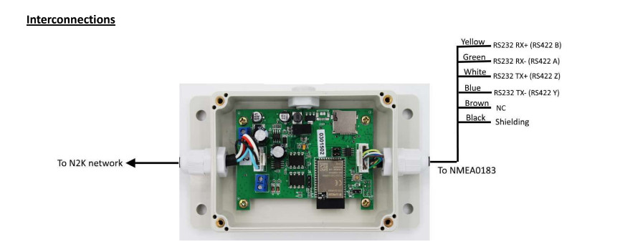

N2K and NMEA0183 bidirectional converter

Note :
- In this manual N2K means NMEA2000
- PGN is the data in the N2K network
Verifying the contents
When you first open the box of your NAVINET KC2W, N2K and NMEA0183 bidirectional converter, please confirm that
you have the following items inside the box:
- NAVINET KC2W main unit attached one end 1.2 meters cable with M12 male 5 pins connector (N2K) and the other
end 1.2 meters cable with open wires (NMEA0183)
- Mounting screws X 4 pcs.
- Manual (quick installation manual)
Interconnections

Descriptions
NAVINET KC2W is a bi-directional converter, it converts NMEA0183 sentences to N2K PGNs and converts N2K PGNs to
NMEA0183 sentences.
NAVINET KC2W is for individual user or marine electronic company if they want:
- Connect equipment with only support NMEA0183 to the N2K network or vice versa
- Install N2K network onboard but they have equipment onboard only support NMEA0183
- Sharing PGNs and NMEA0183 sentences from their equipment onboard with their mobile phone or tablet

1. External power input
On some circumstance if there is no power from the N2K network you can connect an external power to your
NAVINET KC2W with polarity as shown. The input voltage range is from 9VDC to 30VDC.
Note : Please DO NOT any power to this terminal if there are power from N2K network.
2. Lower LED
It has two functions :
- Power indicator, it lights up when there is power from N2K or you connected the external power input.
- N2K data indicator, it is flashing when there are data detected on N2K network
Status 1 : There are PGN input and output on N2K port, quick flash 1 second then light up 1 second
alternatively
Status 2 : Only PGN output appear on N2K port (no input), quick flash 1 second and OFF 1 second
alternatively
Status 3 : Only PGN input appear on N2K port(no output), light up 1 second and OFF 1 second alternatively.
Status 4 : No PGN input or output on N2K port, light up only indicate power up.
3. Upper LED
It is NMEA0183 data indicator
Status 1 : There are NMEA0183 sentences input and output appear on NMEA0183 port, quick flash 1
second and light up 1 second alternatively
Status 2 : Only NMEA0183 sentences output appear on NMEA0183 port (no input), quick flash 1 second
and OFF 1 second alternatively.
Status 3 : Only NMEA0183 sentences input appear on NMEA0183 port (no output), light up 1 second and
OFF 1 second alternatively.
Status 4 : No NMEA0183 sentences input or output appear on NMEA0183 port, OFF
4. WIFI module
It has two functions :
- You can connect NMEA0183 sentences or N2K PGNs to mobile or tablet.
- Configuration and firmware update

