NaviNet SmartBoat System
User Manual
תוכן
1
NaviNet SmartBoat System 1
Overview 1
Supported Systems via App Control 1
MFD Display 2
Features for Boats Over 20 Meters 3
Additional Features 3
System Components 4
Anchor Control Instructions 4
Weigh Anchor (Retract Chain) 4
Drop Anchor (Release Chain) 4
Anchor Speed Configuration 4
Anchor Screen View 📷 Figure 2 – Anchor Operation Screen 5
Connect to internet Instructions 5
This feature enables to operate the system over the internet 5
1. Select setting > wifi setting 5
2. Press connect to server 5
3. Enter ssid hotspot name and password 5
4. Optionally – leave blank or enter server ip and port 5
5. Press save 5
6. Reboot the system . 6
Software Upgrades 6
📥 Upgrade Steps: 6
6
7
Sensor Example 7

Overview
NaviNet SmartBoat your ultimate solution for seamless boat management. With our mobile web app, you can effortlessly control various boat systems from any device. Enjoy the convenience of receiving real-time sensor data, automated activations based on your personalized settings, and integrated alarm systems for enhanced safety. Whether you're on board or miles away, control your boat locally or remotely with ease.

Supported Systems via App Control
You can control the following systems through the app:
- Wireless relay and sensor operation using WIFI, 433MHz, or Zigbee standards
- Bow thruster – left/right control
- Electric sail operation
- Electric winches
- Automatic navigation light activation at pre-set times (currently in development)
- Automatic engine light activation when the engine is running (currently in development)
- Anchor control – raising and lowering via app
  - The app detects and displays the length of anchor chain being lowered
  - ✅ No sensor required – compatible with winch-only systems

MFD Display
MFD (Multi-Function Display) allows viewing of data from multiple sensors, including but not limited to:
- Barometric pressure
- RPM
- Oil pressure
- Water tank levels
- ...and many others
There is no limit to the number of supported sensors.

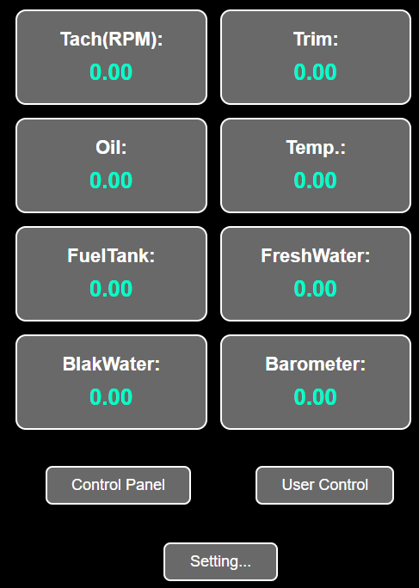

Features for Boats Over 20 Meters
For larger vessels, the system supports automatic visual and audio signaling in compliance with COLREGS (International Regulations for Preventing Collisions at Sea).
- For example: activate with one button during fog to trigger required signals.

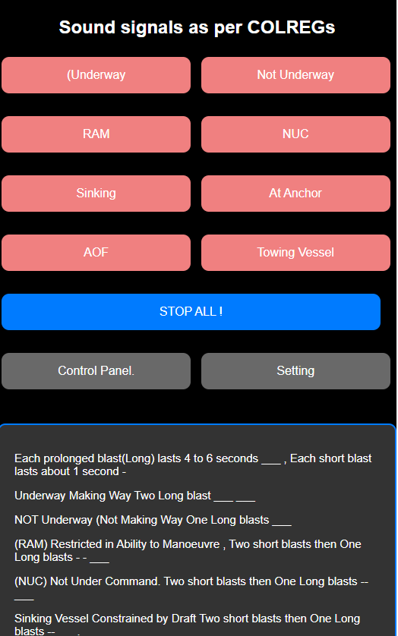

Additional Features
- Bilge pump control
- Water intrusion detection and alert system
- Voice command by Siri

System Components
📷 Figure 1 – System Components Overview
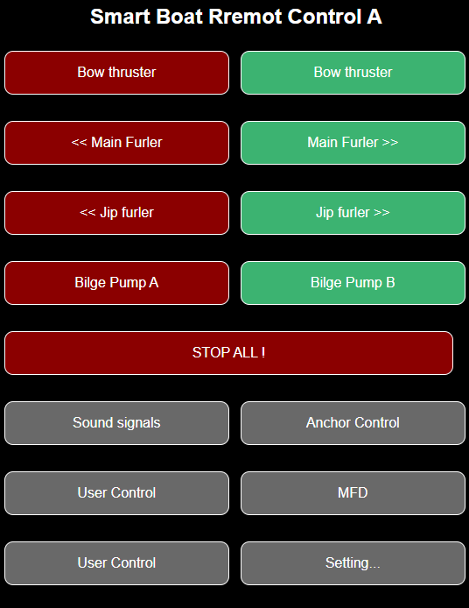
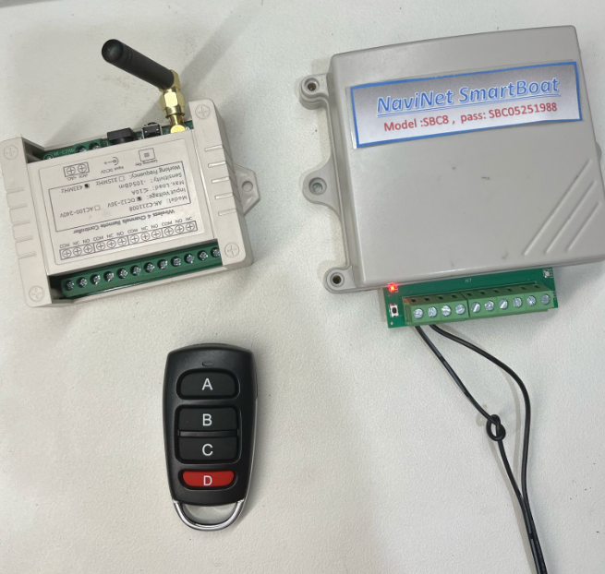

Anchor Control Instructions

Weigh Anchor (Retract Chain)
- Press once to begin, press again to stop.
- Value shown: Retracted – total length (in meters) of released chain so far.

Drop Anchor (Release Chain)
- Press once to begin, press again to stop.
- Value shown: Releasing – the current chain length (in meters) being released during lowering.

Anchor Speed Configuration
- Meters per second – Set this to match your anchor windlass speed
- Maximum chain length – Set the maximum anchor chain length of your boat
This value also lets you define how much chain to release automatically.
⚠️ Beep every second:
Stay alert during anchor drop or retrieval – audible alerts are active.

Anchor Screen View
📷 Figure 2 – Anchor Operation Screen
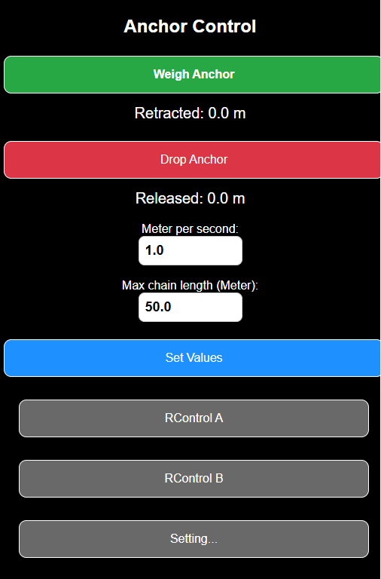

Connect to internet Instructions

This feature enables to operate the system over the internet

Select setting > wifi setting

Press connect to server

Enter ssid hotspot name and password

Optionally – leave blank or enter server ip and port

Press save

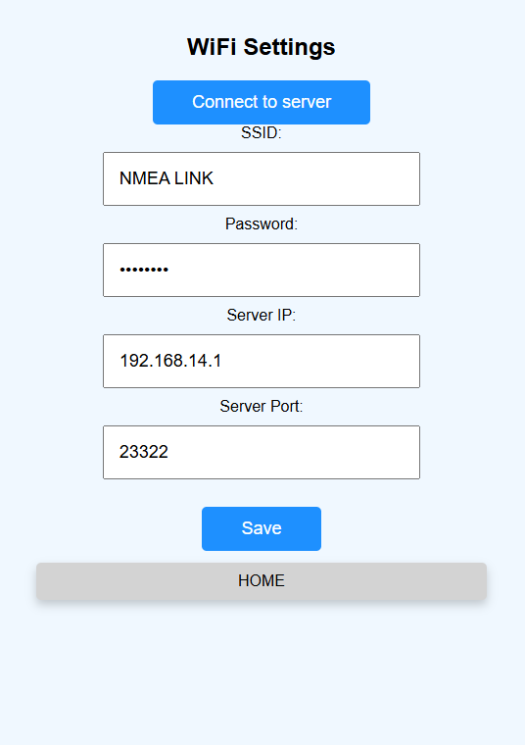
Reboot the system .

Software Upgrades
You can upgrade the system software via Wi-Fi from a computer or smartphone.

📥 Upgrade Steps:
- Download the latest firmware file: V_xxx.bin (from NaviNet web site)
- Power on the system and connect to NaviNet autopilot
- Open the app, go to:
Settings > Software Uploads
- Access the upgrade page:
http://192.168.4.1:8080/page17
- Choose your .bin file
- Enter system password
- Click Upload and wait for completion
- Click Home to return to main screen

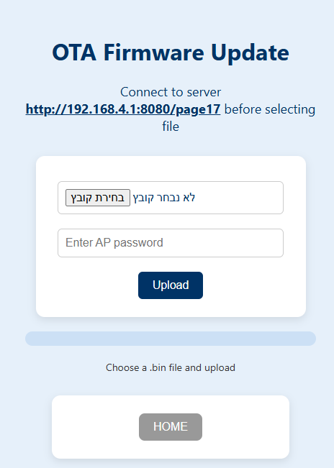

Sensor Example
(wifi sensors:)
Ultrasonic Wind Sensor (0–60 m/s, 360° Precision)
Ultrasonic Wind Speed & Direction Sensor Module.
360° integrated, high-precision, weather-grade anemometer for marine environments.
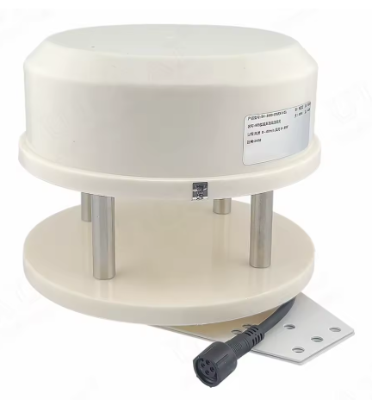


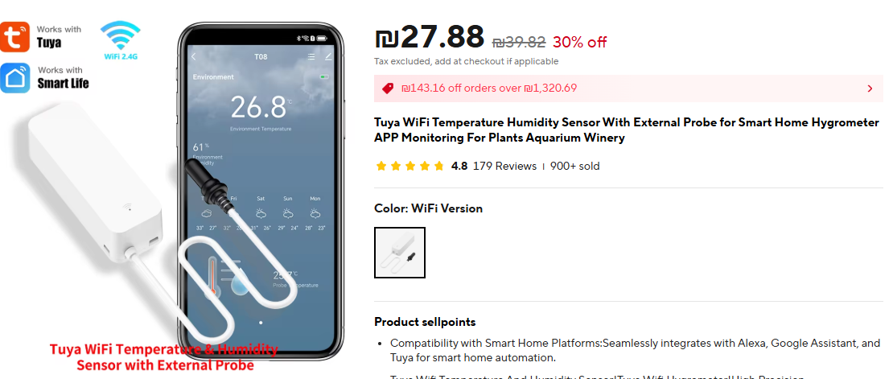
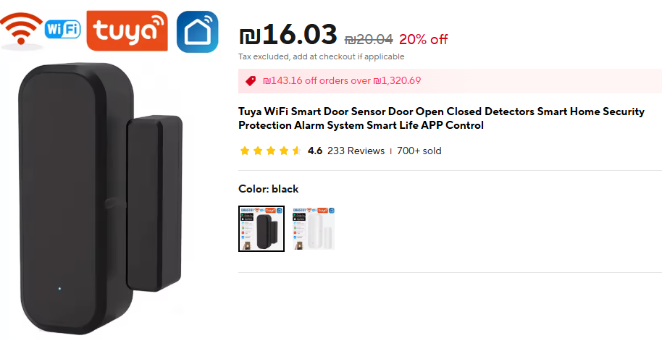
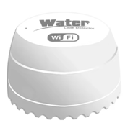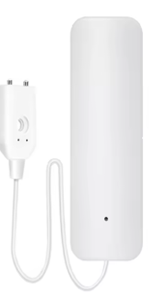

(RF 433Mhz relays & sensors:)
433Mhz Universal Wireless Remote Control Switch 30A DC 12V-85V High Power 1000 Met Relay Receiver for Pump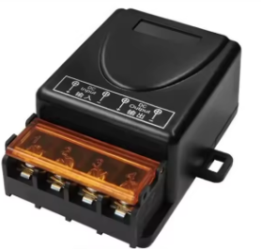

4CH R3 Pro R3 433mhz 4 Gang RF Wireless Remote
