User Manual NaviNet Autopilot

Based on the PYPILOT project by Sean D'Epagnier. Full credit is given to the original author

Table of Contents
🧩 1. Hardware and Installation 3
🔧 Product Installation Location 3
Product components 4
Power Supply 5
Connection to Chartplotter 5
2. Post-Installation System Hardware Settings 6
Boat Balance Offset 6
Rudder Offset (With Rudder Feedback Sensor Installed) 7
Rudder Feedback (Optional Sensor) 8
Rudder Limit Switches (Optional) 8
Wind Sensor Offset 8
The Clutch (המצמד) 9
Emergency Clutch Override / Standby Mode 9
Temperature, Voltage, and Current Sensors 9
Remote Control 10
📈 Next Up: Wiring Diagrams and System Parameter Profiles 11
🗂 4. Installation Diagrams & System Profiles 11
🖥️ Installation Diagrams (Wiring) 11
System Parameter Control – Profiles 15
🔄 Benefits of Using Profiles 15
Profile Tuning Parameters (PID) 15
🔧 Tunable Parameters: 15
🔄 Quick Tuning Example: 15
Recommended PID by Sea Conditions 16
Available user Profile Names: 16
Rudder Movement Speed 17
SM.max_current (Maximum Current) 17
⬆️⬇️ SM.slew_speed / SM.slew_slow 17
SM.period 18
SM.speed.min 18
SM.speed.max 18
servo.use_brake 18
Temperature Sensor Parameter 19
📱 App Access 19
20
How to Access APP: 20
Main App Control Panel 20
Enable / Disable Autopilot 20
Performing a Tack 21
HTW – Heading to Wind 21
Operation Modes 21
Compass Mode 21
GPS Mode 21
NAV / TRACK Mode (Chart plotter) 21
WIND Mode 22
TRUE WIND Mode 22
SmartBoat Mode 22
Tack Parameters 22
TACK DELAY 22
Tack Angle 22
tack.rate (Tack Speed) 22
Tack Threshold 23
HTW – Heading to Wind 23
NMEA0183 – Supported Protocols 23
📥 Received NMEA0183 Sentences (from external systems) 23
📤 Transmitted NMEA0183 Sentences (sent by NaviNet) 23
🔌 Connection Options 24
Software Upgrades 24
📥 Upgrade Steps: 24
Technical Specifications 24
Alerts (Appendix A) 25
🧭 Common Alert Messages: 25

🧩 1. Hardware and Installation
For detailed installation, refer to the NaviNet Autopilot hardware installation instructions.
Important: Before installing, verify that the steering motor (linear or hydraulic pump) is operational in both directions.

🔧 Product Installation Location
The system includes two separate units connected by cable or optionally via Wi-Fi:
- Main Control Unit (MCU32):
Contains the 9-axis IMU compass.
Mount it centrally on the boat, secured with screws, away from electromagnetic interference (high-power cables, metals, speakers, transmitters).
Recommended distance:
  - ~0.5 meters from interference sources
  - ~1 meter from metal hull sides
  - On metal-hulled boats, install on the mast.
- Motor Controller Unit (MDC20A):
Install at 0.5–10 meters from the MCU32.
Consider these environmental factors:
  - Ventilation: Ensure proper airflow.
  - Mounting surface: Must be stable and secure.
  - Cabling: Ensure proper routing and connections.
  - Water exposure:
    - MCU32: IP67 waterproof – can be installed above deck.
    - MDC20A: for below deck only.
  - Electrical interference: Keep away from engines, generators, and radios.
  - Power source: Connect to the device battery, not the engine starter battery.

Product components

MCU32 MDC20A
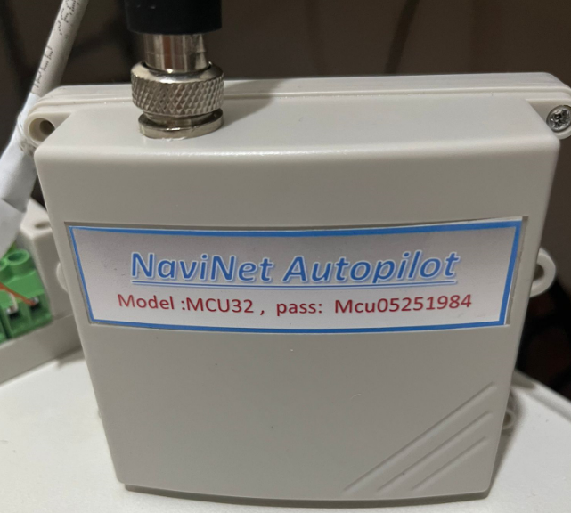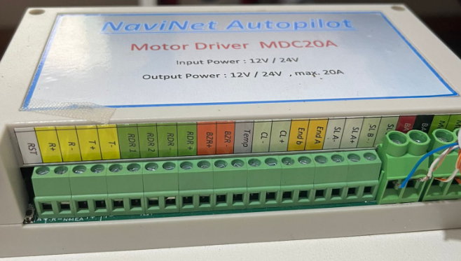

CABLE & 4 KEY REMOT CONTROL
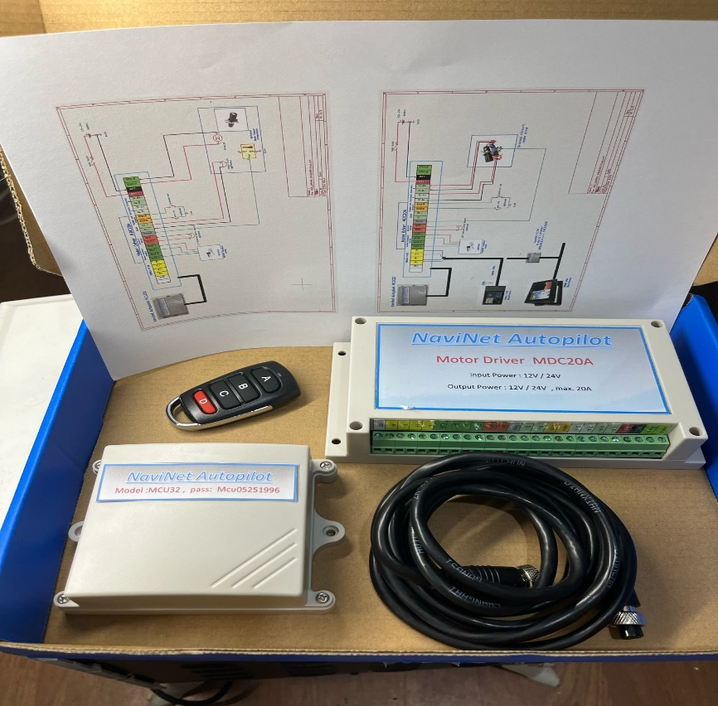

Power Supply
- The MCU is powered by the motor controller and includes protection circuits against overvoltage, reverse polarity, and short circuits.
- The MDC20A must be connected to the battery with thick wires (gauge 4) for 12V or 24V.
- A 20A fuse is built into the motor controller. To replace it, remove the cover.

Connection to Chartplotter
The system supports any chartplotter with:
- NMEA0183 or
- NMEA2000 protocols
- Wired or Wi-Fi connections

Wired – NMEA0183:
- Connect your chart plotter's NMEA0183 RS422 port to MDC20A NMEA0183 RS422 port. (refer to installations manual)
- Check your chart plotter's NMEA baud rate (usually 38400 or 4800).
- The autopilot default is 38400 – change only if needed:
  - Power on MDC20A.
  - Connect via Wi-Fi to “NMEA0183 GATEWAY” (password on unit).
  - Open browser at 192.168.4.1
  - Set baud rate to match (4800 or 38400) and click Save.

Wired – NMEA2000:
- Use protocol converter model KC2W.
- No additional settings required.

Wi-Fi Connection:
- If your plotter supports Wi-Fi:
  - Wi-Fi name: NMEA-LINK
  - Password: (on product label)
  - IP: 192.168.14.1
  - Port: 20220

2. Post-Installation System Hardware Settings
After completing hardware installation and while the boat is docked in the marina, a few offset calibrations must be configured.

Boat Balance Offset
Navigate to:
Settings > Calibration
Click: Perform Boat Balancing
On the MFD screen, ensure that PITCH and ROLL values are 0 – this means the boat is now balanced on both X and Y axes.
Now calculate compass Z-offset as follows:
- Let X = the boat’s known compass heading (from physical compass)
- Let Y = heading shown in the MFD app
- Then, Z = X – Y
For example:
If X = 179° and Y = 10°, then Z = 169
So you need to input Z = -169 into the system.
📝 The allowed compass offset range is:
−180° to +180°
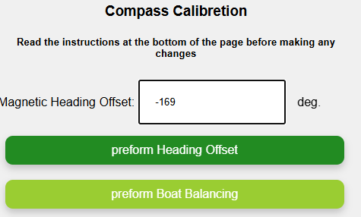

Rudder Offset (With Rudder Feedback Sensor Installed)
Navigate to:
Settings > Rudder Settings
- Set max rudder range to 90, then click Submit
- Center the rudder manually
  - Click Reset, then Centered
- Turn rudder fully to starboard → click Starboard
- Turn rudder fully to port → click Port
- Click Default, then Submit
  - The value will change to 60, allowing ±30° rudder range
Check in MFD:
- Rudder centered: RUDDE = 0
- Max right: RUDDE = -30
- Max left: RUDDE = +30
Use the 1+ / 1− buttons to fine-tune movement and verify physically that the steering motor doesn't hit its mechanical limits.
If steering exceeds 30° during test:
- Decrease the Max Rudder Range value gradually and repeat the test.
If you do NOT have rudder feedback installed, skip this section.
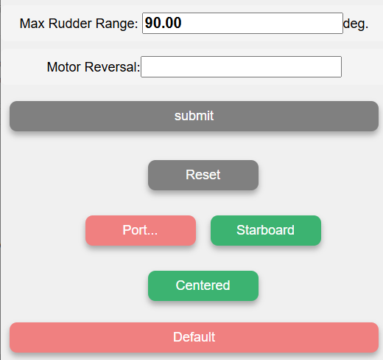

Rudder Feedback (Optional Sensor)
The autopilot will work even without a rudder feedback sensor.
If a feedback sensor is installed (possibly from another autopilot system), it can be connected in parallel to NaviNet via a designated terminal.
- Compatible potentiometer range: 1kΩ – 100kΩ
- The motor controller supplies 5V to the sensor
- See wiring diagram for parallel connection to other systems.

Rudder Limit Switches (Optional)
Limit switches prevent further movement when closed.
- Helpful in large boat systems to reduce mechanical strain
- Switches short to GND when triggered
- Connect to pins marked End-A and End-B on the motor controller

Wind Sensor Offset
Navigate to:
Settings > Wind
- Enter the offset values in the relevant fields
- Click Submit
- Verify that wind speed shown on MFD P2 matches boat instruments
- 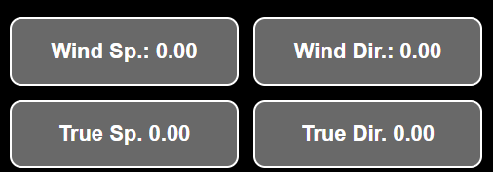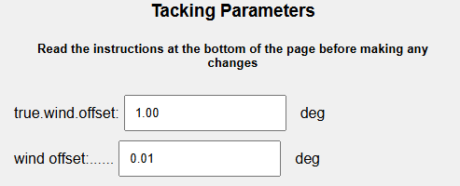

The Clutch (המצמד)
In larger or specialized steering systems, a clutch may be used:
- Typically activates a solenoid (hydraulic) or electromechanical clutch
- Activation pattern:
  - Full power for 200–300 ms
  - Then reduced to PWM signal to maintain clutch engagement
  - This reduces power consumption

Emergency Clutch Override / Standby Mode
Essential to maintain the ability to manually control the rudder quickly if needed.
- On systems without a clutch (e.g., electromechanical or larger hydraulic setups), it’s strongly recommended to install a manual switch near the helm.
- The supplied remote control (red button) can also be used for this.

Temperature, Voltage, and Current Sensors
- The motor controller includes 2 internal temperature sensors
  - Displayed on MFD P2 screen
- You can also monitor motor/pump temperature externally:
  - Connect an NTC 10k sensor to the TEMP pin
Default maximum motor temperature: 60°C
- Crossing this threshold can trigger alerts
- Indicates a need for maintenance or brush replacement
- 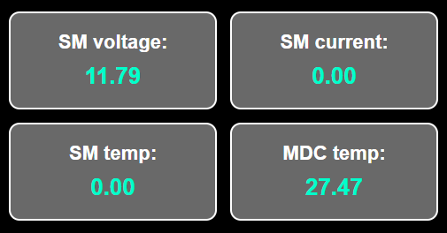

Remote Control
The remote has 4 buttons and allows full autopilot control:

STANDBY Mode D (Red Button)
- Long press B = +10
- Long press C = −10

AUTO Mode Active
- Short press B = +10
- Short press C = −10
- Press A + B = Tack right
- Press A + C = Tack left
✔️ Waterproof versions available:
- Acceptable 3-button ,4-button ,and 6-button models

Reset All Remotes control
- In Settings, click Reset all RC

Pair a New Remote control
- Go to Settings > Pairing new RC
- After beep, press button A on the new remote
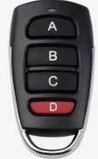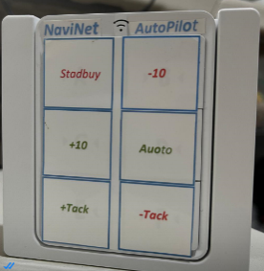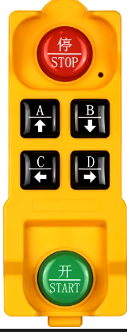

📈 Next Up: Wiring Diagrams and System Parameter Profiles

🗂 4. Installation Diagrams & System Profiles

🖥️ Installation Diagrams (Wiring)
The NaviNet system supports various installation configurations. Schematics include:
- Parallel Connection with Another Autopilot System
  - Allows NaviNet to work alongside an existing autopilot for redundancy (backup system)
- Steering Motor for Yachts up to 47 Feet
  - Direct connection for typical mid-size yachts
- Steering Motor with Solenoid for Large Boats
  - Supports complex steering systems using hydraulic solenoids
📌 See the official installation manual diagrams for full wiring visuals (not included here textually due to format)

Parallel Connection with Another Autopilot System
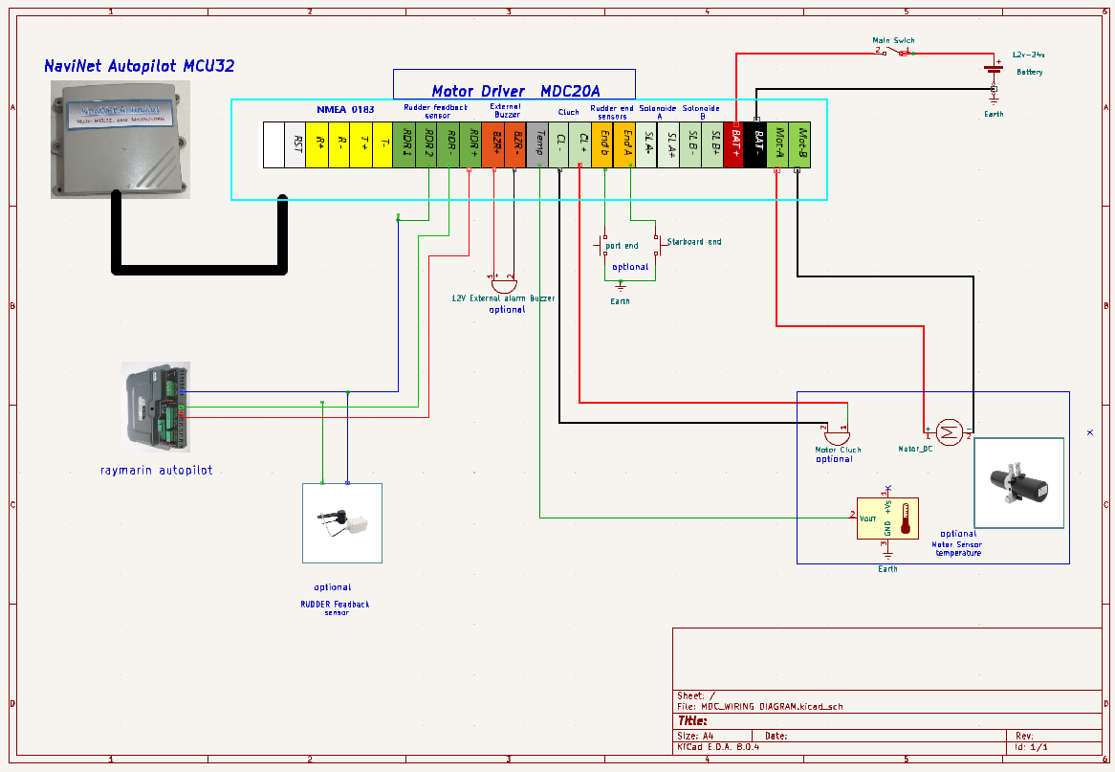

- Steering Motor for Yachts up to 47 Fee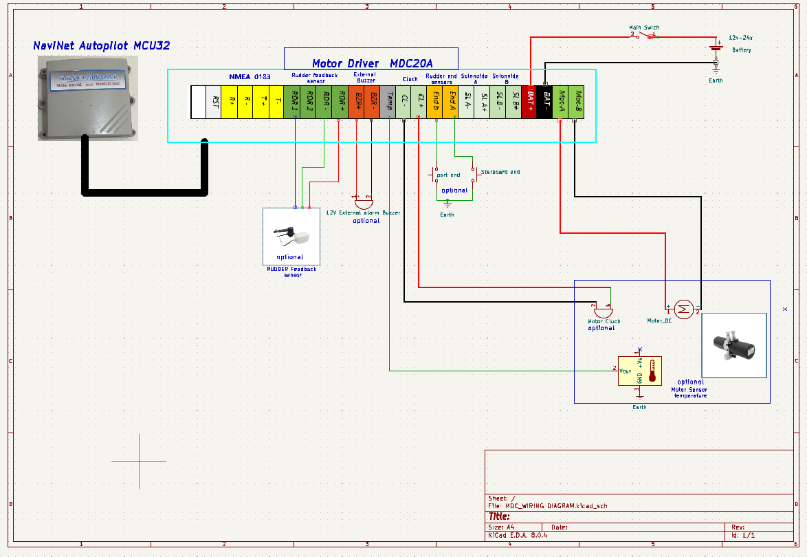

Steering Motor with Solenoid for Large Boat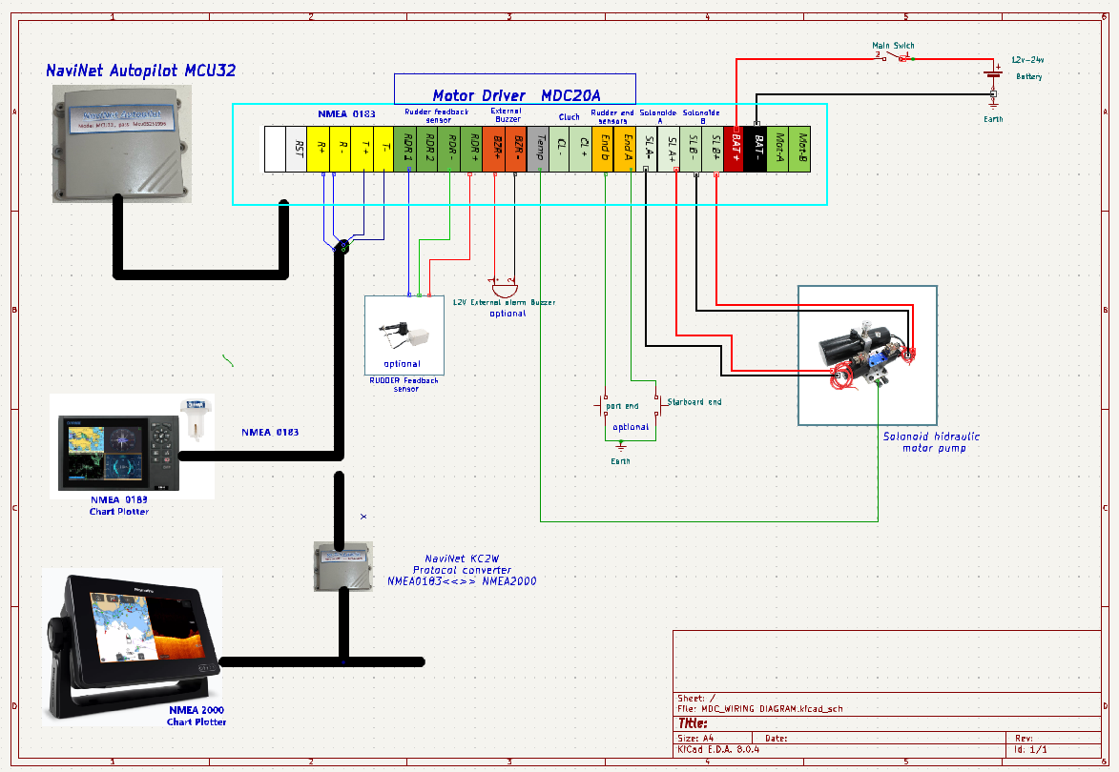

System Parameter Control – Profiles
NaviNet supports multiple profiles to quickly adjust autopilot settings for different sea conditions.
These profiles include:
- PID tuning parameters
- Servo configurations
- Motor behavior

🔄 Benefits of Using Profiles
- Quickly switch settings when sailing in different conditions
- Reduces energy consumption, improves steering, and minimizes noise
- Especially useful for optimizing behavior in light winds, heavy seas, or fast motoring

Profile Tuning Parameters (PID)
The system uses an enhanced PID filter for steering loop control.
Most users don’t need to change these – preconfigured profiles are usually enough.

🔧 Tunable Parameters:
Parameter | Description
P | Proportional gain – based on current heading error
I | Integral gain – accumulates past error
D | Derivative – reacts to rate of heading change
DD | Second derivative – anticipates turning behavior
PR | Proportional root – sqrt of heading error, reduces oscillation
FF | Feed-forward – anticipates direction changes
I | (Again) Can correct long-term drift from heading/course

🔄 Quick Tuning Example:
- Start basic:
  - Set P = 0.003, D = 0.01, other values = 0
- If boat lags behind course:
  - Increase both P and D
- If boat overcorrects / steers too much:
  - Decrease both P and D

Recommended PID by Sea Conditions
Sea State | P | I | D | DD | FF | Notes
Calm (Beaufort 0–1) | 0.015–0.020 | 0.0005–0.001 | 0.2–0.3 | 0.02 | 0.7–1.0 | Minimal corrections, low noise
Moderate (2–4) | 0.025–0.035 | 0.001–0.002 | 0.3–0.5 | 0.03 | 1.0–1.2 | Balance response & power
Rough (5–6) | 0.035–0.050 | 0.002–0.004 | 0.5–0.7 | 0.04–0.05 | 1.2–1.5 | Fast aggressive corrections
Strong Side Wind | 0.025–0.030 | 0.0015–0.002 | 0.3–0.4 | 0.03 | 1.5–2.0 | High FF to compensate lateral force
High-Speed Motor Sailing | 0.040–0.060 | 0.003 | 0.5–0.6 | 0.04 | 1.0 | DD helps prevent oversteering

Available user Profile Names:
- Default
- motorboat
- profil_1
- profil_2
Each can be user-configured.
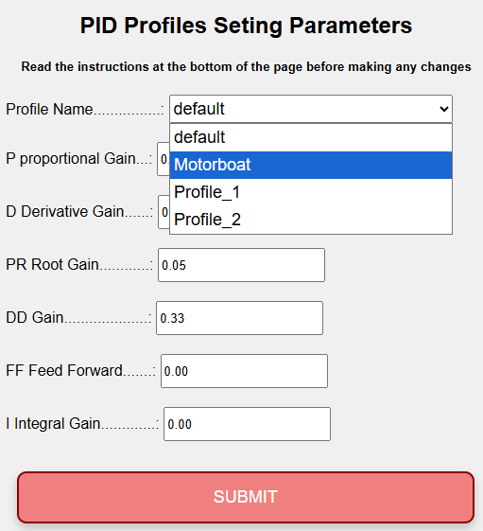

Servo Motor Configuration
Proper tuning of the servo motor parameters is key for effective autopilot performance.

Rudder Movement Speed
The speed at which the motor can turn the rudder has major impact on how well the autopilot performs.
- Generally aim for rudder movement of ±30° in 6–8 seconds
- On larger boats, slower speeds are acceptable
- In light winds, slower rudder motion is fine
- In heavy seas or upwind currents, fast response is critical
SM DIRECTION
- Controls motor rotation direction (without changing wiring)
- Set in: Settings > Rudder Settings
Value | Description
1+ | Default direction
1− | Reverse motor direction
Recommendation:
- Servo wire positive to terminal A, negative to terminal B
- Use software direction adjustment as needed

SM.max_current (Maximum Current)
- Defines stall detection threshold for the servo motor
- Too low: motor may not move
- Too high: autopilot may keep trying after motor stalls (risk!)
Typical Values
4–7A for small tiller drives
15–20A for hydraulic or large systems
17A - Default

⬆️⬇️ SM.slew_speed / SM.slew_slow
- Set acceleration/deceleration for smoother motor control
- Helps reduce current spikes and allows lower current thresholds
| Recommended range: 15–30 |
Too low = slow response
Too high = jerky or noisy control

SM.period
- Minimum on/off time for motor
- Prevents rapid, short bursts that wear out motor and waste power
| Typical value: 0.3–0.4 sec |
- Higher values: better for big boats or light sea states
- Lower values: better for fast, responsive boats or rough conditions

SM.speed.min
- Minimum speed allowed for the servo motor
- Prevents inefficient slow rotations
- Encourages short, fast corrections, rather than long low-power adjustments

SM.speed.max
- Maximum speed of servo
- Can be lowered in calm conditions to reduce:
  - Noise
  - Power consumption
  - Mechanical wear

servo.use_brake
- When enabled, prevents the rudder from pushing the motor backward in heavy weather
- Most useful on mono-hull boats with unbalanced rudders (sailing upwind)
Recommended: leave disabled unless absolutely necessary

Temperature Sensor Parameter
- If installing an external temperature sensor (on servo motor), you can define:
  - Max allowed motor temperature
| Default: 60°C |
- Above this: system alerts for overheating
- Can indicate the need to replace brushes or inspect the motor
📱 App Access
The NaviNet Autopilot app is web-based, meaning:
- No installation needed
- Works on any mobile device or computer
- Supports multi-screen views for better control (see example pic. in the original manual)
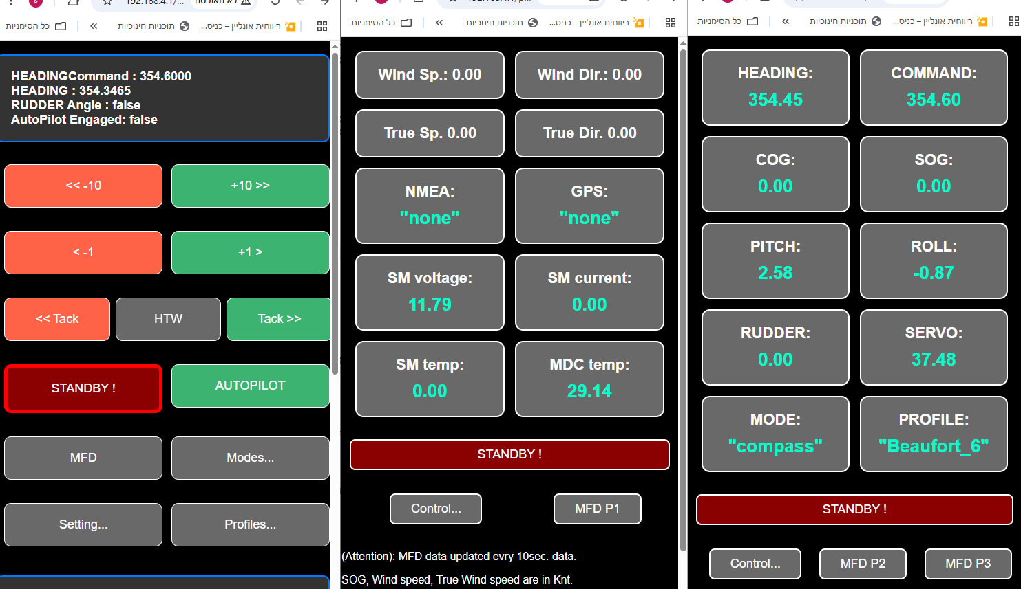

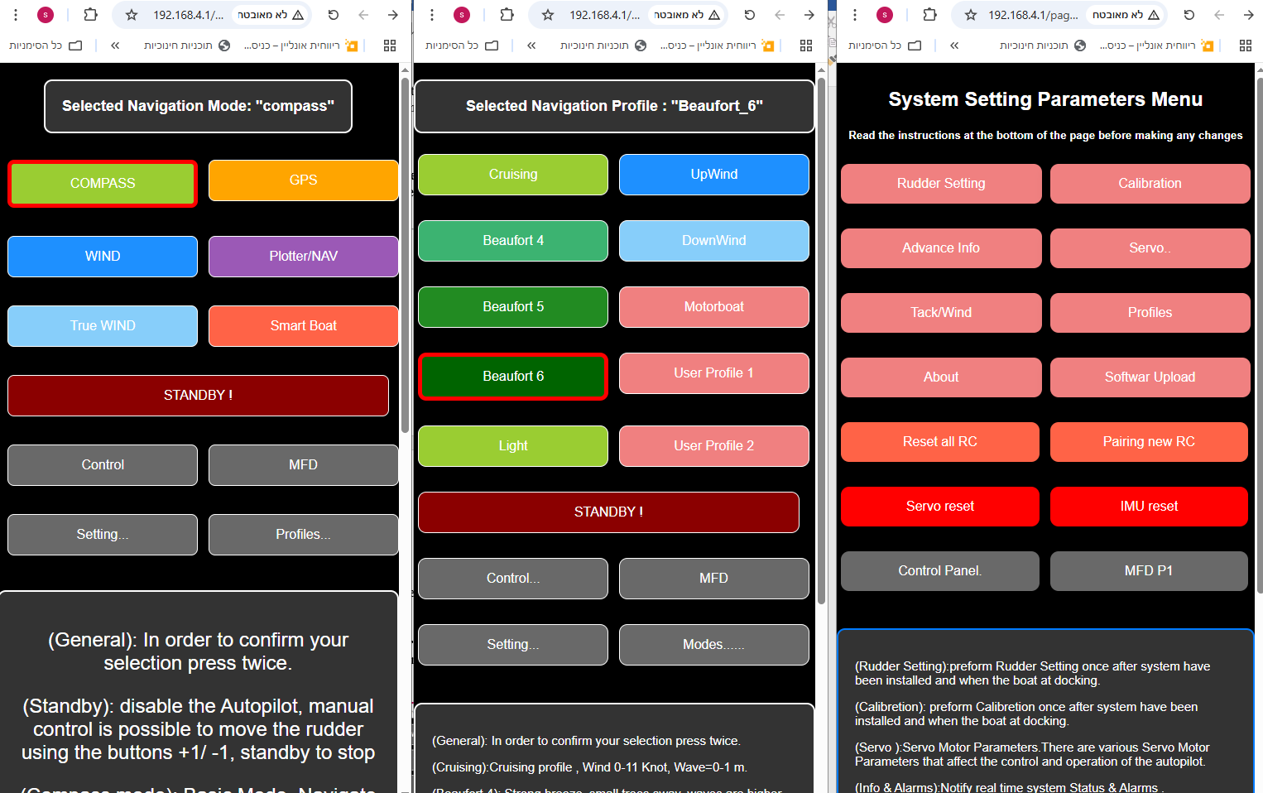

How to Access APP:
- Power on the system
- Wait for 2 beeps (initialization complete) , it may tack about 2 seconds,
- Connect to Wi-Fi network: NaviNet pilot
- Enter system password (printed on the unit)
- Open any browser and go to: http://192.168.4.1
- (Tip) Save the address as a favorite for easier access
⚠️ For safety, the app can be active on only one device at a time.

Main App Control Panel

Enable / Disable Autopilot
- AUTO = activate autopilot
- STANDBY = deactivate autopilot
- In STANDBY, you can move the rudder using:
  - 1+ / 1− buttons in the app
  - Remote buttons B (right) and C (left)

Performing a Tack
In AUTO mode, click Tack on the control panel:
- Right (Green) → tack starboard
- Left (Red) → tack port
- To cancel a tack in progress: press STANDBY

HTW – Heading to Wind
- Forces the boat to turn directly into the wind
- Ideal when raising or lowering the mainsail
- Especially helpful in single-handed mode

Operation Modes
Navigate to: Modes Menu

Compass Mode
- Uses internal 9-axis compass
- Always available, even if GPS or other data is missing
- Recommended starting point to test system reliability

GPS Mode
- Uses GPS data to maintain a fixed ground direction (COG)
- Doesn’t rely on boat heading – compensates for drift
- Helps when compass data has magnetic variation
Still uses compass and gyros for fast adjustments

NAV / TRACK Mode (Chart plotter)
- Similar to GPS mode
- Uses NMEA0183 APB messages from chart plotter
- Enables automatic steering along a waypoint route
e.g., when reaching a waypoint, autopilot turns toward the next automatically

WIND Mode
- Uses wind angle data (from wind sensors)
- Keeps boat pointed at a set apparent wind angle
- Great for upwind sailing or in shifting winds

TRUE WIND Mode
- Combines wind angle, boat speed (SOG), and water movement
- Calculates true wind angle and steers accordingly
- Especially helpful for downwind sailing with gusts

SmartBoat Mode
- Enables integration with NaviNet SmartBoat system
- Requires Wi-Fi connection between NaviNet and SmartBoat
- See the SmartBoat manual for specific pairing instructions

Tack Parameters
Tack settings let you customize how the autopilot performs a tack.

TACK DELAY
- Wait time before starting tack
- Useful for single-handed sailors to prepare the jib before turn starts

Tack Angle
- Common: 90° to 120°
- Depends on boat type, wind speed, and sea conditions

tack.rate (Tack Speed)
- Tack rotation rate (° per second)
- Common range: 20–50°/sec
- Faster = quicker tack, depending on rudder speed

Tack Threshold
- Defines when tack is considered complete
- 100% = wait until exact angle is reached
- 45% = switch to new course mid-turn (used to avoid over-steering)
For example, if tacking from 0° to 100°:
- A 45% threshold might accept 45° as “tack complete”
Lower threshold = less overshoot
Higher threshold = more precise turn

HTW – Heading to Wind
- Forces the boat to turn directly into the wind
- Ideal when raising or lowering the mainsail
- Especially helpful in single-handed mode

NMEA0183 – Supported Protocols
The NaviNet Autopilot supports the NMEA0183 marine communication standard, allowing integration with a wide range of devices.

📥 Received NMEA0183 Sentences (from external systems)
- MWV – Wind speed and angle
- VWR – Relative wind
- VWT – True wind
- APB – Autopilot navigation
- VWH – Waypoint heading
- LWY – Waypoint info
- RMC – GPS position and course
- RSA – Rudder angle

📤 Transmitted NMEA0183 Sentences (sent by NaviNet)
- MWV– Wind speed and angle
- RSA– Rudder angle
- RMC– GPS position and course
- XDR – Transducer data
- HDM – Heading magnetic
- ROT – Rate of turn

🔌 Connection Options
- RS422 port (via motor controller MDC20A)
- Wi-Fi:
  - Wi-Fi SSID: NMEA LINK
  - Port: 20220
  - Password: serial number (on MCU32 unit)
⚠️ Important:
- Always verify compatibility and connection parameters on the chartplotter

Software Upgrades
You can upgrade the system software via Wi-Fi from a computer or smartphone.

📥 Upgrade Steps:
- Download the latest firmware file: V_xxx.bin (from NaviNet web site)
- Power on the system and connect to NaviNet Wi-Fi
- Open the app, go to:
Settings > Software Uploads
- Access the upgrade page:
http://192.168.4.1:8080/page17
- Choose your .bin file
- Enter system password
- Click Upload and wait for completion
- Click Home to return to main screen

Technical Specifications
Component | MCU32 | MDC-20A | MDC-30A
Voltage | 12V/24V | 12V/24V | 12V/24V
Idle Current | 240 | 52 mA | 52 mA
Power | 280-W | 62-W | 62-W
USB | 280-mA | - | -
MDC | - | 20 A | A 28
Fuse | Internal | 20 A | 30 A

Alerts (Appendix A)
You can view detailed alert messages in the app:
Settings > Advanced Info

🧭 Common Alert Messages:
Code | Meaning
SYNC | MCU and motor controller are communicating
OVERTEMP_FAULT | Motor or controller exceeded temperature limit
OVERCURRENT_FAULT | Overcurrent protection triggered
ENGAGED | System actively steering
VOLTAGE_FAULT | Battery voltage out of acceptable range
BAD_FUSES | Fuse blown
PORT_OVERCURRENT_FAULT | Left turn caused overcurrent
STARBOARD_OVERCURRENT_FAULT | Right turn caused overcurrent
DRIVER_TIMEOUT | No current detected after motor command – may be ignored if current sensing is off
Motor too slow | Indicates motor speed too low to follow command – may need faster motor
Reboot flag set | Controller rebooted
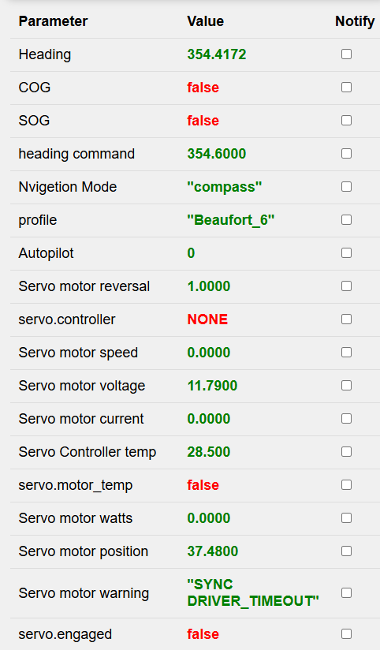 | 