

[**User Manual NaviNet Autopilot**](https://www.translatoruser.net/bvsandbox.aspx?&from=en&to=he&csId=6feafc22-f2e8-44eb-9bd6-c29e187a7552&usId=28a4642f-12ce-47f1-a04c-a811b47cb948&ac=true&bvrpx=false&bvrpp=&dt=2025%2F4%2F15%200%3A15#_Toc184259950)

Based on the PYPILOT project by Sean D'Epagnier. Full credit is given to the original author

**Table of Contents**

**🧩 1. Hardware and Installation** 3

**🔧 Product Installation Location** 3

Product components 4

**Power Supply** 5

**Connection to Chartplotter** 5

**2. Post-Installation System Hardware Settings** 6

**Boat Balance Offset** 6

**Rudder Offset (With Rudder Feedback Sensor Installed)** 7

**Rudder Feedback (Optional Sensor)** 8

**Rudder Limit Switches (Optional)** 8

**Wind Sensor Offset** 8

**The Clutch (המצמד)** 9

**Emergency Clutch Override / Standby Mode** 9

**Temperature, Voltage, and Current Sensors** 9

**Remote Control** 10

**📈 Next Up: Wiring Diagrams and System Parameter Profiles** 11

**🗂 4. Installation Diagrams & System Profiles** 11

**🖥️ Installation Diagrams (Wiring)** 11

**System Parameter Control – Profiles** 15

**🔄 Benefits of Using Profiles** 15

**Profile Tuning Parameters (PID)** 15

**🔧 Tunable Parameters:** 15

**🔄 Quick Tuning Example:** 15

**Recommended PID by Sea Conditions** 16

**Available user Profile Names:** 16

**Rudder Movement Speed** 17

**SM.max_current (Maximum Current)** 17

**⬆️⬇️ SM.slew_speed / SM.slew_slow** 17

**SM.period** 18

**SM.speed.min** 18

**SM.speed.max** 18

**servo.use_brake** 18

**Temperature Sensor Parameter** 19

**📱 App Access** 19

20

**How to Access APP:** 20

**Main App Control Panel** 20

**Enable / Disable Autopilot** 20

**Performing a Tack** 21

**HTW – Heading to Wind** 21

**Operation Modes** 21

**Compass Mode** 21

**GPS Mode** 21

**NAV / TRACK Mode (Chart plotter)** 21

**WIND Mode** 22

**TRUE WIND Mode** 22

**SmartBoat Mode** 22

**Tack Parameters** 22

**TACK DELAY** 22

**Tack Angle** 22

**tack.rate (Tack Speed)** 22

**Tack Threshold** 23

**HTW – Heading to Wind** 23

**NMEA0183 – Supported Protocols** 23

**📥 Received NMEA0183 Sentences (from external systems)** 23

**📤 Transmitted NMEA0183 Sentences (sent by NaviNet)** 23

**🔌 Connection Options** 24

**Software Upgrades** 24

**📥 Upgrade Steps:** 24

**Technical Specifications** 24

**Alerts (Appendix A)** 25

**🧭 Common Alert Messages:** 25

**🧩 1. Hardware and Installation**

For detailed installation, refer to the **NaviNet Autopilot hardware installation instructions**.

**Important**: Before installing, verify that the steering motor (linear or hydraulic pump) is operational in both directions.

**🔧 Product Installation Location**

The system includes **two separate units** connected by cable or optionally via Wi-Fi:

* **Main Control Unit (MCU32)**:  
  Contains the 9-axis IMU compass.  
  Mount it **centrally on the boat**, secured with screws, away from electromagnetic interference (high-power cables, metals, speakers, transmitters).  
  Recommended distance:
  + ~0.5 meters from interference sources
  + ~1 meter from metal hull sides
  + On metal-hulled boats, install on the mast.
* **Motor Controller Unit (MDC20A)**:  
  Install at **0.5–10 meters** from the MCU32.  
  Consider these environmental factors:
  + **Ventilation**: Ensure proper airflow.
  + **Mounting surface**: Must be stable and secure.
  + **Cabling**: Ensure proper routing and connections.
  + **Water exposure**:
    - MCU32: IP67 waterproof – can be installed above deck.
    - MDC20A: for below deck only.
  + **Electrical interference**: Keep away from engines, generators, and radios.
  + **Power source**: Connect to the **device battery**, **not** the engine starter battery.

## Product components

MCU32 MDC20A

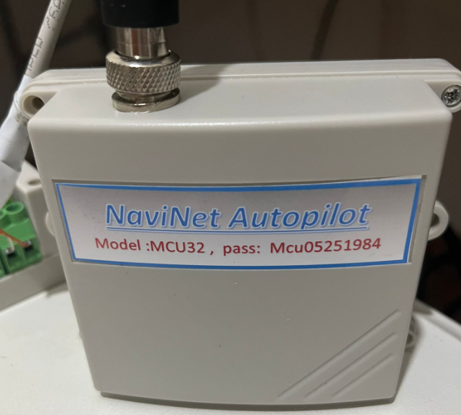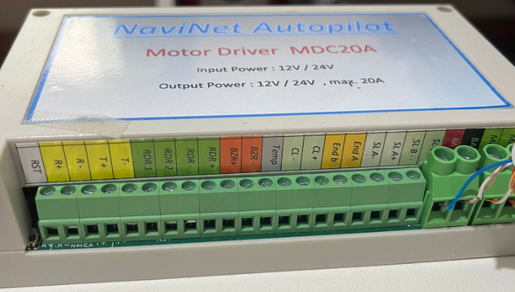

CABLE & 4 KEY REMOT CONTROL

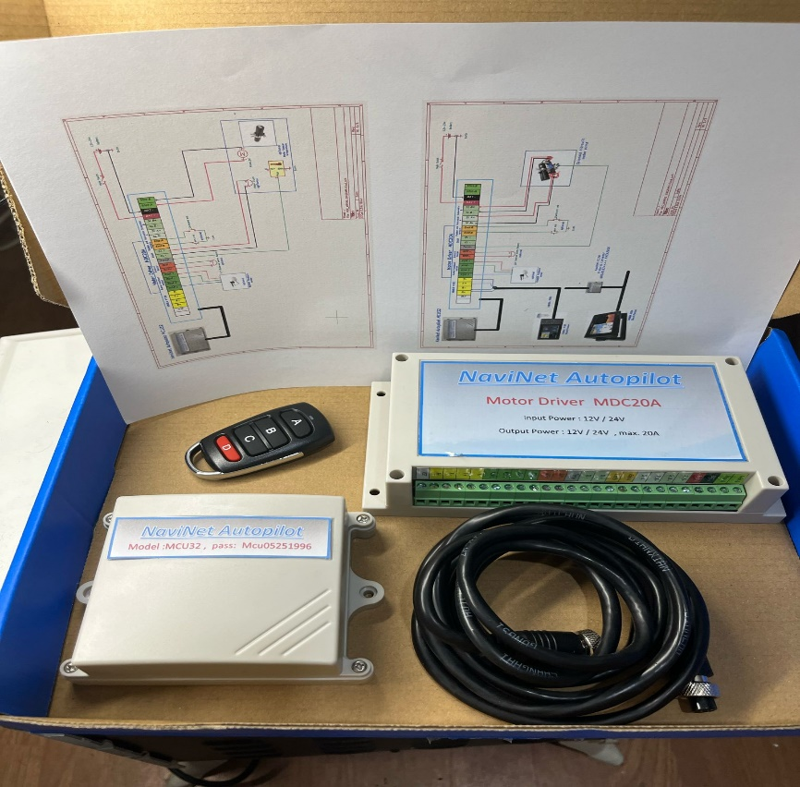

**Power Supply**

* The **MCU** is powered by the **motor controller** and includes protection circuits against overvoltage, reverse polarity, and short circuits.
* The **MDC20A** must be connected to the battery with **thick wires (gauge 4)** for 12V or 24V.
* A 20A fuse is built into the motor controller. To replace it, remove the cover.

**Connection to Chartplotter**

The system supports any chartplotter with:

* NMEA0183 or
* NMEA2000 protocols
* Wired or Wi-Fi connections

**Wired – NMEA0183:**

* Connect your chart plotter's NMEA0183 RS422 port to MDC20A NMEA0183 RS422 port. (refer to installations manual)
* Check your chart plotter's NMEA baud rate (usually 38400 or 4800).
* The autopilot default is **38400** – change only if needed:
  1. Power on MDC20A.
  2. Connect via Wi-Fi to “**NMEA0183 GATEWAY**” (password on unit).
  3. Open browser at 192.168.4.1
  4. Set baud rate to match (4800 or 38400) and click **Save**.

**Wired – NMEA2000:**

* Use protocol converter model **KC2W**.
* No additional settings required.

**Wi-Fi Connection:**

* If your plotter supports Wi-Fi:
  + Wi-Fi name: NMEA-LINK
  + Password: (on product label)
  + IP: 192.168.14.1
  + Port: 20220

**2. Post-Installation System Hardware Settings**

After completing hardware installation and while the boat is docked in the marina, a few offset calibrations must be configured.

**Boat Balance Offset**

Navigate to:  
**Settings > Calibration**  
Click: **Perform Boat Balancing**

On the MFD screen, ensure that **PITCH** and **ROLL** values are **0** – this means the boat is now balanced on both X and Y axes.

Now calculate compass Z-offset as follows:

* Let **X** = the boat’s known compass heading (from physical compass)
* Let **Y** = heading shown in the MFD app
* Then, **Z = X – Y**

For example:  
If X = 179° and Y = 10°, then Z = 169  
So you need to input **Z = -169** into the system.

📝 The allowed compass offset range is:  
**−180° to +180°**

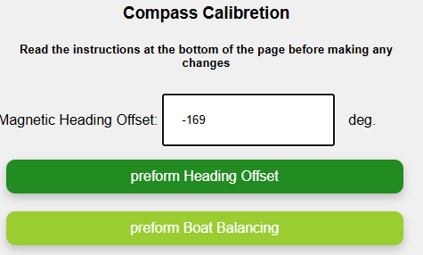

**Rudder Offset (With Rudder Feedback Sensor Installed)**

Navigate to:  
**Settings > Rudder Settings**

1. Set **max rudder range** to **90**, then click **Submit**
2. Center the rudder manually
   * Click **Reset**, then **Centered**
3. Turn rudder fully to starboard → click **Starboard**
4. Turn rudder fully to port → click **Port**
5. Click **Default**, then **Submit**
   * The value will change to **60**, allowing ±30° rudder range

**Check in MFD:**

* Rudder centered: **RUDDE = 0**
* Max right: **RUDDE = -30**
* Max left: **RUDDE = +30**

Use the **1+** / **1−** buttons to fine-tune movement and verify physically that the steering motor doesn't hit its mechanical limits.

If steering exceeds 30° during test:

* Decrease the **Max Rudder Range** value gradually and repeat the test.

**If you do NOT have rudder feedback installed, skip this section.**

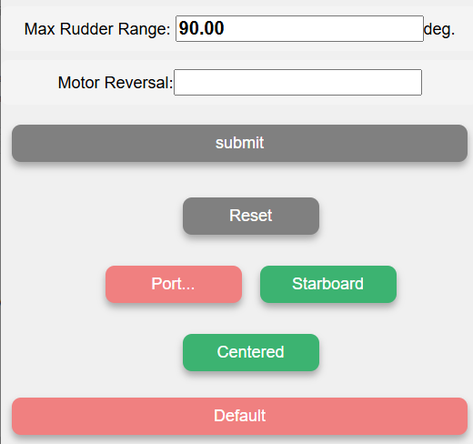

**Rudder Feedback (Optional Sensor)**

The autopilot will work **even without** a rudder feedback sensor.

If a feedback sensor is installed (possibly from another autopilot system), it can be connected **in parallel** to NaviNet via a designated terminal.

* Compatible potentiometer range: **1kΩ – 100kΩ**
* The motor controller supplies **5V** to the sensor
* See wiring diagram for parallel connection to other systems.

**Rudder Limit Switches (Optional)**

Limit switches prevent further movement when closed.

* Helpful in large boat systems to reduce mechanical strain
* Switches short to **GND** when triggered
* Connect to pins marked **End-A** and **End-B** on the motor controller

**Wind Sensor Offset**

Navigate to:  
**Settings > Wind**

* Enter the offset values in the relevant fields
* Click **Submit**
* Verify that wind speed shown on **MFD P2** matches boat instruments
* 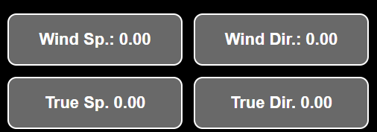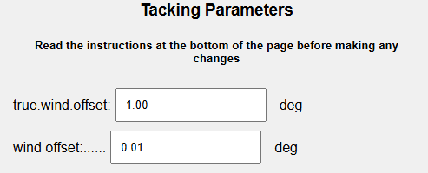

**The Clutch (המצמד)**

In larger or specialized steering systems, a **clutch** may be used:

* Typically activates a **solenoid (hydraulic)** or **electromechanical clutch**
* Activation pattern:
  + Full power for **200–300 ms**
  + Then reduced to **PWM signal** to maintain clutch engagement
  + This reduces power consumption

**Emergency Clutch Override / Standby Mode**

Essential to maintain the ability to **manually control the rudder** quickly if needed.

* On systems **without a clutch** (e.g., electromechanical or larger hydraulic setups), it’s **strongly recommended** to install a **manual switch** near the helm.
* The supplied **remote control** (red button) can also be used for this.

**Temperature, Voltage, and Current Sensors**

* The **motor controller** includes **2 internal temperature sensors**
  + Displayed on **MFD P2** screen
* You can also monitor **motor/pump temperature** externally:
  + Connect an **NTC 10k** sensor to the **TEMP** pin

Default maximum motor temperature: **60°C**

* Crossing this threshold can trigger alerts
* Indicates a need for maintenance or **brush replacement**
* 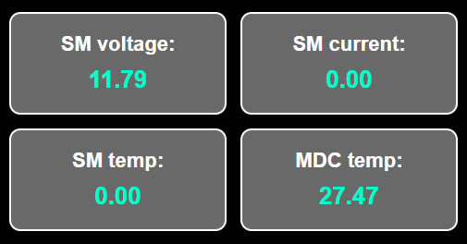

**Remote Control**

The remote has **4 buttons** and allows full autopilot control:

**STANDBY Mode D (Red Button)**

* Long press **B** = +10
* Long press **C** = −10

**AUTO Mode Active**

* Short press **B** = +10
* Short press **C** = −10
* Press **A + B** = Tack right
* Press **A + C** = Tack left

✔️ Waterproof versions available:

* Acceptable 3-button ,4-button ,and 6-button models

**Reset All Remotes control**

* In **Settings**, click **Reset all RC**

**Pair a New Remote control**

* Go to **Settings > Pairing new RC**
* After beep, press button **A** on the new remote

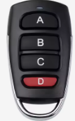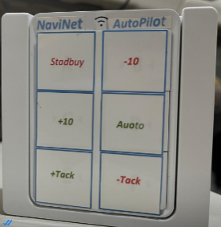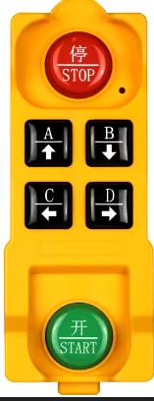

**📈 Next Up: Wiring Diagrams and System Parameter Profiles**

**🗂 4. Installation Diagrams & System Profiles**

**🖥️ Installation Diagrams (Wiring)**

The NaviNet system supports various installation configurations. Schematics include:

1. **Parallel Connection with Another Autopilot System**
   * Allows NaviNet to work alongside an existing autopilot for **redundancy** (backup system)
2. **Steering Motor for Yachts up to 47 Feet**
   * Direct connection for typical mid-size yachts
3. **Steering Motor with Solenoid for Large Boats**
   * Supports complex steering systems using hydraulic solenoids

📌 See the **official installation manual diagrams** for full wiring visuals (not included here textually due to format)

**Parallel Connection with Another Autopilot System**

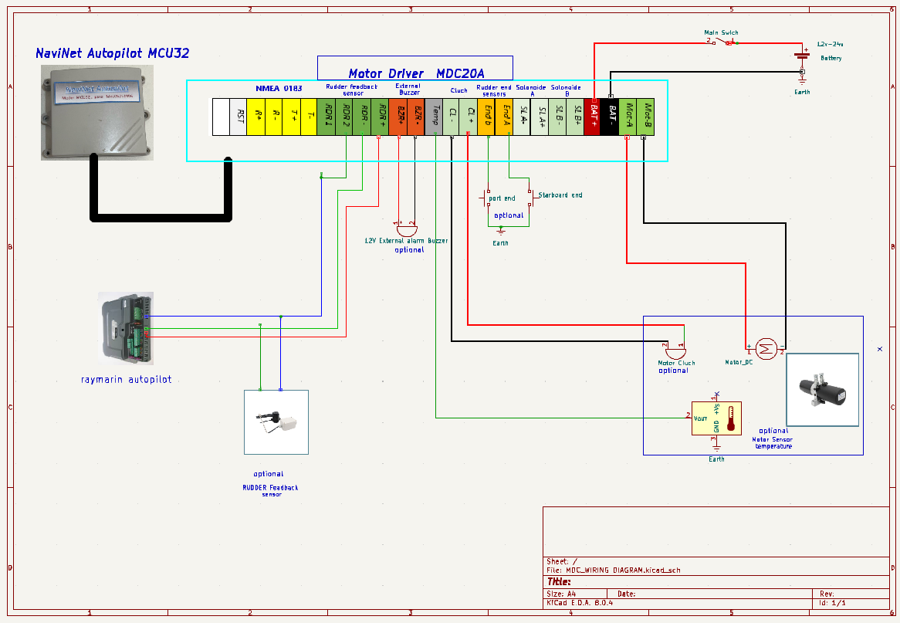

1. **Steering Motor for Yachts up to 47 Fee**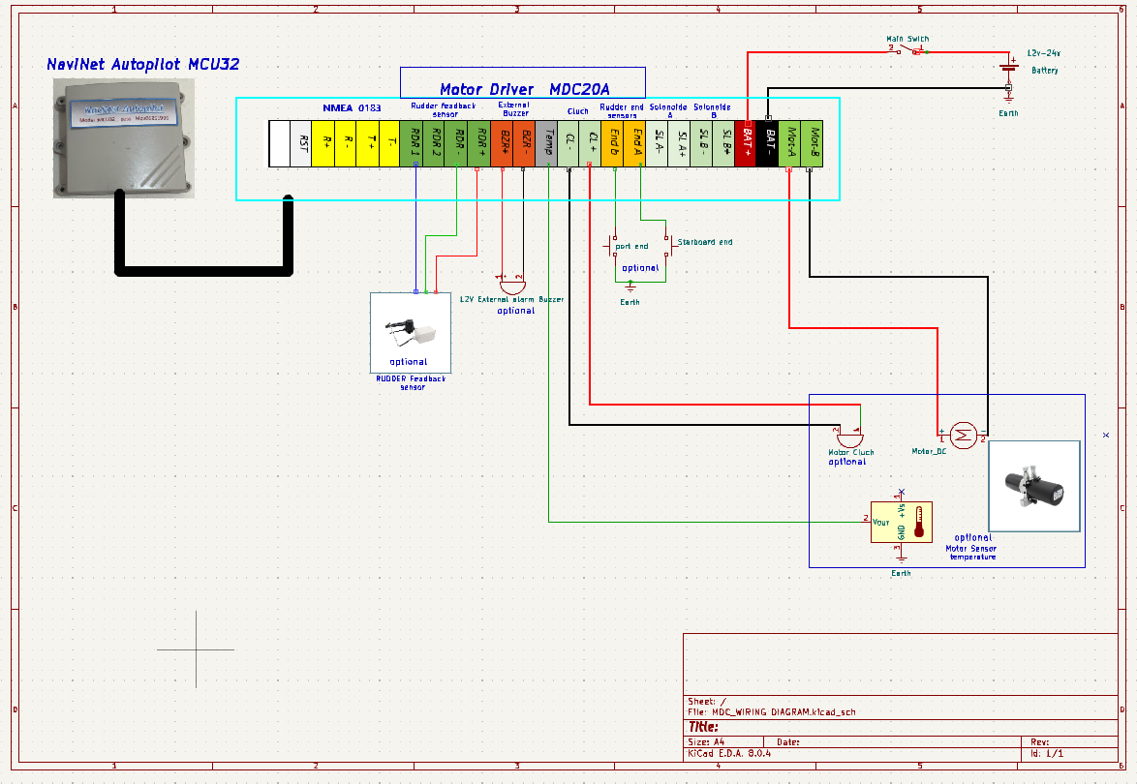

**Steering Motor with Solenoid for Large Boat**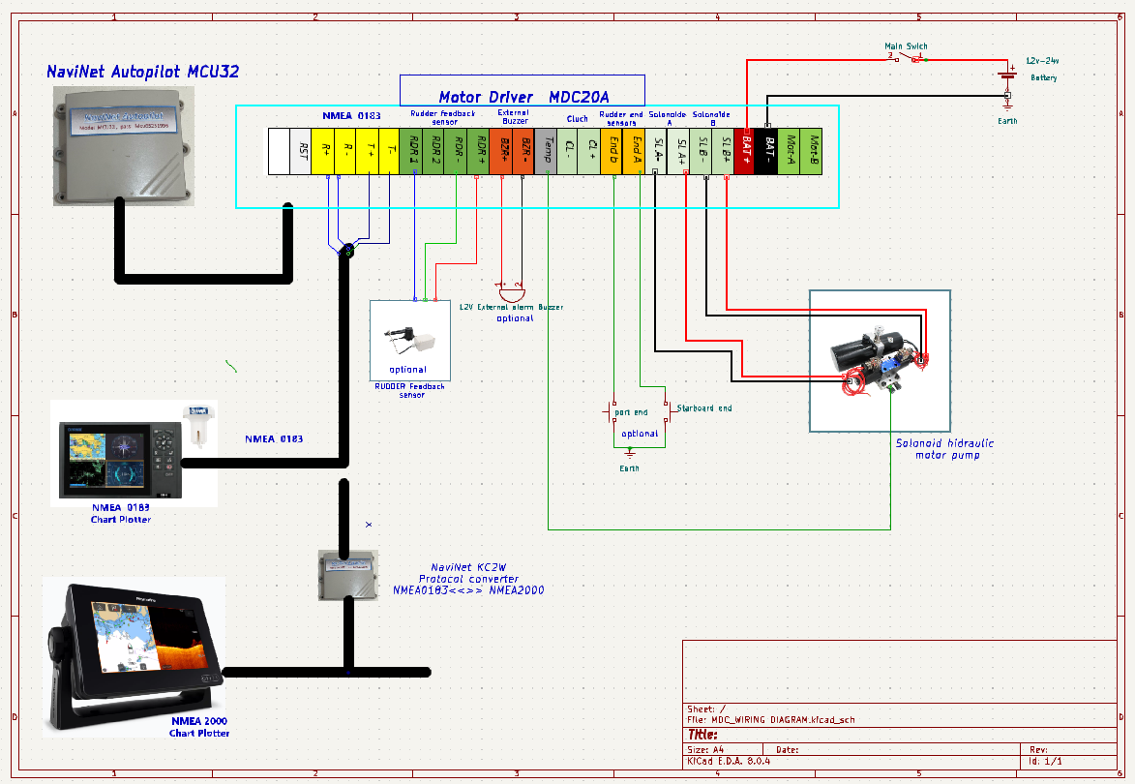

**System Parameter Control – Profiles**

NaviNet supports multiple **profiles** to quickly adjust autopilot settings for different **sea conditions**.

These profiles include:

* PID tuning parameters
* Servo configurations
* Motor behavior

**🔄 Benefits of Using Profiles**

* Quickly switch settings when sailing in different conditions
* Reduces energy consumption, improves steering, and minimizes noise
* Especially useful for optimizing behavior in **light winds**, **heavy seas**, or **fast motoring**

**Profile Tuning Parameters (PID)**

The system uses an **enhanced PID filter** for steering loop control.

Most users **don’t need to change** these – preconfigured profiles are usually enough.

**🔧 Tunable Parameters:**

| **Parameter** | **Description** |
| --- | --- |
| **P** | Proportional gain – based on current heading error |
| **I** | Integral gain – accumulates past error |
| **D** | Derivative – reacts to rate of heading change |
| **DD** | Second derivative – anticipates turning behavior |
| **PR** | Proportional root – sqrt of heading error, reduces oscillation |
| **FF** | Feed-forward – anticipates direction changes |
| **I** | (Again) Can correct long-term drift from heading/course |

**🔄 Quick Tuning Example:**

* **Start basic**:
  + Set **P = 0.003**, **D = 0.01**, other values = 0
* If boat **lags behind course**:
  + Increase both P and D
* If boat **overcorrects / steers too much**:
  + Decrease both P and D

**Recommended PID by Sea Conditions**

| **Sea State** | **P** | **I** | **D** | **DD** | **FF** | **Notes** |
| --- | --- | --- | --- | --- | --- | --- |
| Calm (Beaufort 0–1) | 0.015–0.020 | 0.0005–0.001 | 0.2–0.3 | 0.02 | 0.7–1.0 | Minimal corrections, low noise |
| Moderate (2–4) | 0.025–0.035 | 0.001–0.002 | 0.3–0.5 | 0.03 | 1.0–1.2 | Balance response & power |
| Rough (5–6) | 0.035–0.050 | 0.002–0.004 | 0.5–0.7 | 0.04–0.05 | 1.2–1.5 | Fast aggressive corrections |
| Strong Side Wind | 0.025–0.030 | 0.0015–0.002 | 0.3–0.4 | 0.03 | 1.5–2.0 | High FF to compensate lateral force |
| High-Speed Motor Sailing | 0.040–0.060 | 0.003 | 0.5–0.6 | 0.04 | 1.0 | DD helps prevent oversteering |

**Available user Profile Names:**

* Default
* motorboat
* profil_1
* profil_2

Each can be user-configured.

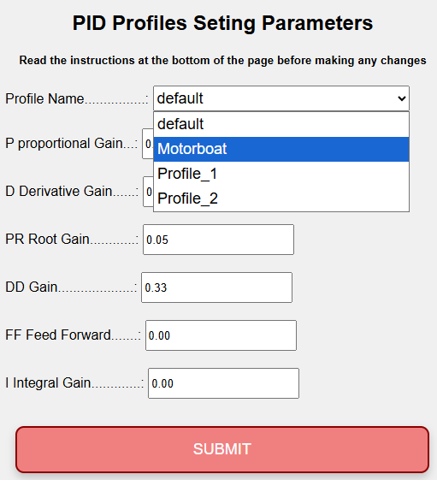

**Servo Motor Configuration**

Proper tuning of the **servo motor parameters** is key for effective autopilot performance.

**Rudder Movement Speed**

The speed at which the motor can turn the rudder has **major impact** on how well the autopilot performs.

* Generally aim for rudder movement of **±30° in 6–8 seconds**
* On **larger boats**, slower speeds are acceptable
* In **light winds**, slower rudder motion is fine
* In **heavy seas** or **upwind currents**, **fast response is critical**

**SM DIRECTION**

* Controls motor **rotation direction** (without changing wiring)
* Set in: **Settings > Rudder Settings**

| **Value** | **Description** |
| --- | --- |
| 1+ | Default direction |
| 1− | Reverse motor direction |

Recommendation:

* Servo wire **positive to terminal A**, **negative to terminal B**
* Use software direction adjustment as needed

**SM.max_current (Maximum Current)**

* Defines **stall detection threshold** for the servo motor
* Too **low**: motor may not move
* Too **high**: autopilot may keep trying after motor stalls (risk!)

| **Typical Values** |
| --- |
| **4–7A** for small tiller drives |
| **15–20A** for hydraulic or large systems |
| **17A** - Default |

**⬆️⬇️ SM.slew_speed / SM.slew_slow**

* Set **acceleration/deceleration** for smoother motor control
* Helps reduce **current spikes** and allows **lower current thresholds**

| Recommended range: **15–30** |

Too low = slow response  
Too high = jerky or noisy control

**SM.period**

* Minimum **on/off time** for motor
* Prevents rapid, short bursts that wear out motor and waste power

| Typical value: **0.3–0.4 sec** |

* **Higher** values: better for big boats or light sea states
* **Lower** values: better for fast, responsive boats or rough conditions

**SM.speed.min**

* Minimum speed allowed for the servo motor
* Prevents **inefficient slow rotations**
* Encourages **short, fast corrections**, rather than long low-power adjustments

**SM.speed.max**

* Maximum speed of servo
* Can be **lowered** in calm conditions to reduce:
  + Noise
  + Power consumption
  + Mechanical wear

**servo.use_brake**

* When enabled, prevents the rudder from pushing the motor backward in heavy weather
* Most useful on **mono-hull boats** with **unbalanced rudders** (sailing upwind)

**Recommended: leave disabled unless absolutely necessary**

**Temperature Sensor Parameter**

* If installing an external temperature sensor (on servo motor), you can define:
  + **Max allowed motor temperature**

| Default: **60°C** |

* Above this: system alerts for **overheating**
* Can indicate the need to **replace brushes** or inspect the motor

**📱 App Access**

The NaviNet Autopilot app is **web-based**, meaning:

* No installation needed
* Works on **any mobile device or computer**
* Supports **multi-screen views** for better control (see example pic. in the original manual)

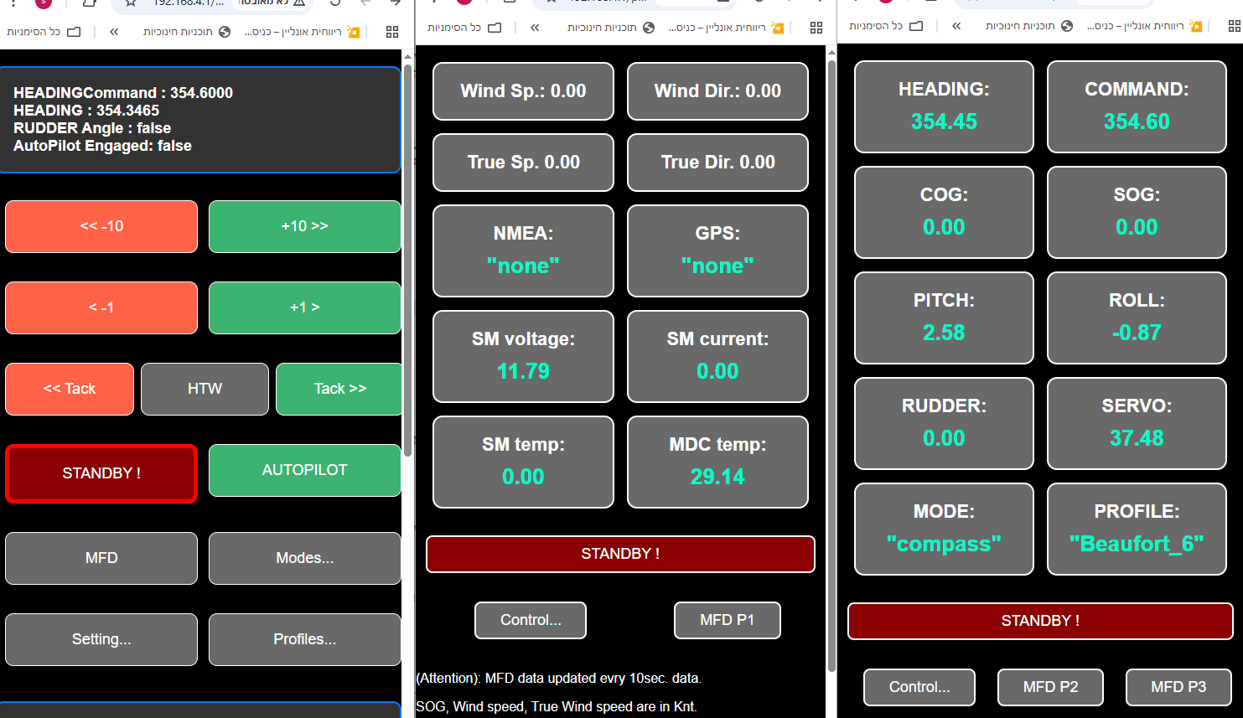

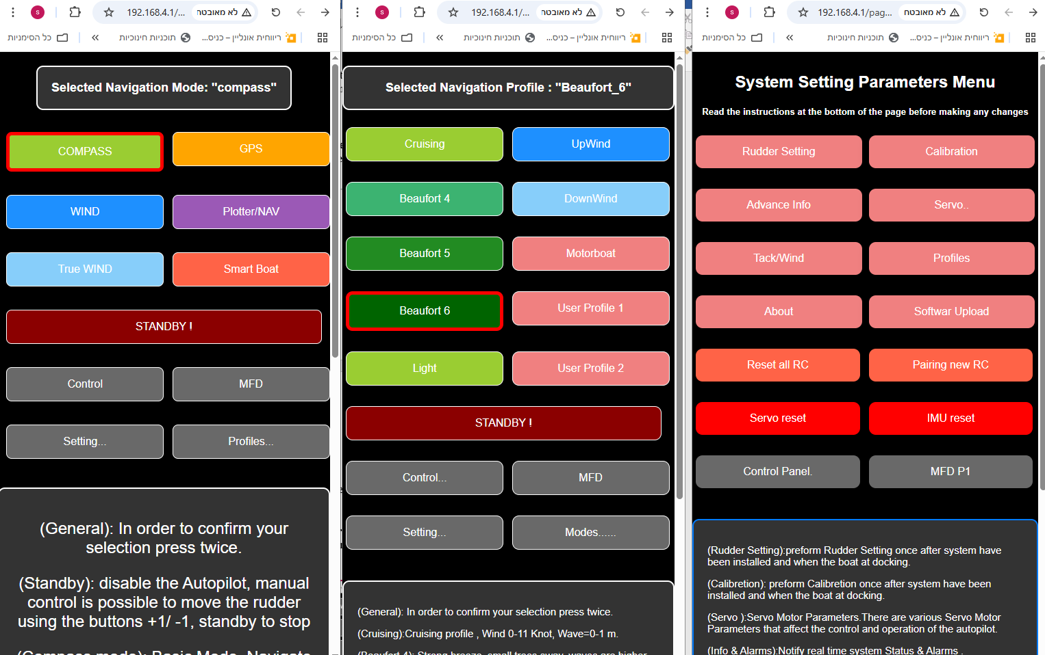

**How to Access APP:**

1. Power on the system
2. Wait for **2 beeps** (initialization complete) , it may tack about 2 seconds,
3. Connect to Wi-Fi network: NaviNet pilot
4. Enter system **password** (printed on the unit)
5. Open any browser and go to: http://192.168.4.1
6. (Tip) Save the address as a favorite for easier access

⚠️ For safety, the app can be **active on only one device at a time**.

**Main App Control Panel**

**Enable / Disable Autopilot**

* **AUTO** = activate autopilot
* **STANDBY** = deactivate autopilot
* In STANDBY, you can move the rudder using:
  + **1+ / 1−** buttons in the app
  + Remote buttons **B (right)** and **C (left)**

**Performing a Tack**

In **AUTO mode**, click **Tack** on the control panel:

* **Right (Green)** → tack starboard
* **Left (Red)** → tack port
* To cancel a tack in progress: press **STANDBY**

**HTW – Heading to Wind**

* Forces the boat to turn **directly into the wind**
* Ideal when raising or lowering the mainsail
* Especially helpful in **single-handed mode**

**Operation Modes**

Navigate to: **Modes Menu**

**Compass Mode**

* Uses internal 9-axis compass
* Always available, even if GPS or other data is missing
* Recommended starting point to test system reliability

**GPS Mode**

* Uses GPS data to maintain a fixed **ground direction (COG)**
* Doesn’t rely on boat heading – compensates for drift
* Helps when compass data has magnetic variation

Still uses compass and gyros for fast adjustments

**NAV / TRACK Mode (Chart plotter)**

* Similar to GPS mode
* Uses **NMEA0183 APB messages** from chart plotter
* Enables automatic steering along a **waypoint route**

e.g., when reaching a waypoint, autopilot turns toward the next automatically

**WIND Mode**

* Uses wind angle data (from wind sensors)
* Keeps boat pointed at a set **apparent wind angle**
* Great for upwind sailing or in shifting winds

**TRUE WIND Mode**

* Combines wind angle, boat speed (SOG), and water movement
* Calculates **true wind angle** and steers accordingly
* Especially helpful for **downwind sailing** with gusts

**SmartBoat Mode**

* Enables integration with **NaviNet SmartBoat system**
* Requires Wi-Fi connection between NaviNet and SmartBoat
* See the SmartBoat manual for specific pairing instructions

**Tack Parameters**

Tack settings let you customize how the autopilot performs a tack.

**TACK DELAY**

* Wait time before starting tack
* Useful for single-handed sailors to **prepare the jib** before turn starts

**Tack Angle**

* Common: **90° to 120°**
* Depends on boat type, wind speed, and sea conditions

**tack.rate (Tack Speed)**

* Tack rotation rate (° per second)
* Common range: **20–50°/sec**
* Faster = quicker tack, depending on rudder speed

**Tack Threshold**

* Defines when tack is considered **complete**
* **100%** = wait until exact angle is reached
* **45%** = switch to new course mid-turn (used to avoid over-steering)

For example, if tacking from 0° to 100°:

* A 45% threshold might accept 45° as “tack complete”

**Lower threshold** = less overshoot  
**Higher threshold** = more precise turn

**HTW – Heading to Wind**

* Forces the boat to turn **directly into the wind**
* Ideal when raising or lowering the mainsail
* Especially helpful in **single-handed mode**

**NMEA0183 – Supported Protocols**

The NaviNet Autopilot supports the **NMEA0183 marine communication standard**, allowing integration with a wide range of devices.

**📥 Received NMEA0183 Sentences (from external systems)**

* MWV – Wind speed and angle
* VWR – Relative wind
* VWT – True wind
* APB – Autopilot navigation
* VWH – Waypoint heading
* LWY – Waypoint info
* RMC – GPS position and course
* RSA – Rudder angle

**📤 Transmitted NMEA0183 Sentences (sent by NaviNet)**

* MWV– Wind speed and angle
* RSA– Rudder angle
* RMC– GPS position and course
* XDR – Transducer data
* HDM – Heading magnetic
* ROT – Rate of turn

**🔌 Connection Options**

* RS422 port (via **motor controller MDC20A**)
* Wi-Fi:
  + Wi-Fi SSID: NMEA LINK
  + Port: 20220
  + Password: serial number (on MCU32 unit)

⚠️ **Important**:

* Always verify compatibility and connection parameters on the chartplotter

**Software Upgrades**

You can upgrade the system software via **Wi-Fi** from a computer or smartphone.

**📥 Upgrade Steps:**

1. Download the latest firmware file: V_xxx.bin (from NaviNet web site)
2. Power on the system and connect to NaviNet Wi-Fi
3. Open the app, go to:  
   **Settings > Software Uploads**
4. Access the upgrade page:  
   http://192.168.4.1:8080/page17
5. Choose your .bin file
6. Enter system password
7. Click **Upload** and wait for completion
8. Click **Home** to return to main screen

**Technical Specifications**

|  |  |  |  |
| --- | --- | --- | --- |
| **Component** | **MCU32** | **MDC-20A** | **MDC-30A** |
| Voltage | 12V/24V | 12V/24V | 12V/24V |
| Idle Current | 240 | 52 mA | 52 mA |
| Power | 280-W | 62-W | 62-W |
| USB | 280-mA | - | - |
| MDC | - | 20 A | A 28 |
| Fuse | Internal | 20 A | 30 A |

**Alerts (Appendix A)**

You can view detailed alert messages in the app:  
**Settings > Advanced Info**

**🧭 Common Alert Messages:**

| **Code** | **Meaning** |
| --- | --- |
| SYNC | MCU and motor controller are communicating |
| OVERTEMP_FAULT | Motor or controller exceeded temperature limit |
| OVERCURRENT_FAULT | Overcurrent protection triggered |
| ENGAGED | System actively steering |
| VOLTAGE_FAULT | Battery voltage out of acceptable range |
| BAD_FUSES | Fuse blown |
| PORT_OVERCURRENT_FAULT | Left turn caused overcurrent |
| STARBOARD_OVERCURRENT_FAULT | Right turn caused overcurrent |
| DRIVER_TIMEOUT | No current detected after motor command – may be ignored if current sensing is off |
| Motor too slow | Indicates motor speed too low to follow command – may need faster motor |
| Reboot flag set | Controller rebooted |
|  |  |
|  |  |

